Issues in Meet:

- Restart your device to make sure it has received all updates. (Completely shut down - do not put into sleep mode or just close the device)

- Make sure you're signing in with an @aalk8.org email address. (Accounts that end with @gmail.com may be restricted)

- Make sure you are using a compatible browser:
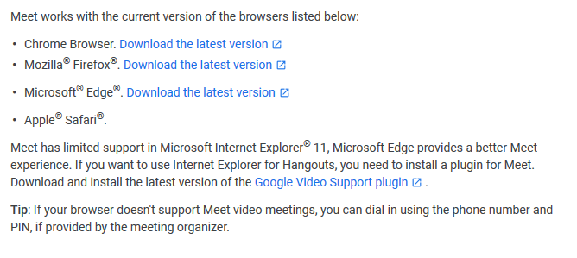
- Also make sure that your browser is updated. Visit this site to test if your browser is updated: Browser Update or click settings in your browser and select update. In addition, you can learn more about updating a specific browser here: How to Update a Browser.

- Visit this site and run a test. This will let us know if it is a hardware issue. Here is the site: Hardware test The site will also test internet connections. If there is an issue with internet speed, please contact your internet service provider in regards to increasing speed.

- If you are still unable to get meet working on your computer, there is an app available for any of your mobile devices.

- If your issue persists please contact technical support.

